

Semester Two Examination, 2022

Question/Answer booklet

MATHEMATICS SPECIALIST
UNITs 3&4

Section One:

Calculator-free

Your Name

Your Teacher’s Name

Time allowed for this section
Reading time before commencing work: five minutes
Working time: fifty minutes

Materials required/recommended for this section
To be provided by the supervisor
This Question/Answer booklet
Formula sheet

To be provided by the candidate
Standard items: pens (blue/black preferred), pencils (including coloured), sharpener, correction fluid/tape, eraser, ruler, highlighters

Special items: nil

Important note to candidates
No other items may be taken into the examination room. It is your responsibility to ensure that you do not have any unauthorised material. If you have any unauthorised material with you, hand it to the supervisor before reading any further.
Question | Mark | Max | Question | Mark | Max
1 |  | 5 | 5 |  | 6
2 |  | 13 | 6 |  | 5
3 |  | 5 | 7 |  | 5
4 |  | 5 | 8 |  | 5

Structure of this paper

Section | Number of questions available | Number of questions to be answered | Working time (minutes) | Marks available | Percentage of examination
Section One:  Calculator-free | 8 | 8 | 50 | 49 | 35
Section Two:  Calculator-assumed | 11 | 11 | 100 | 97 | 65
 |  |  |  | Total | 100

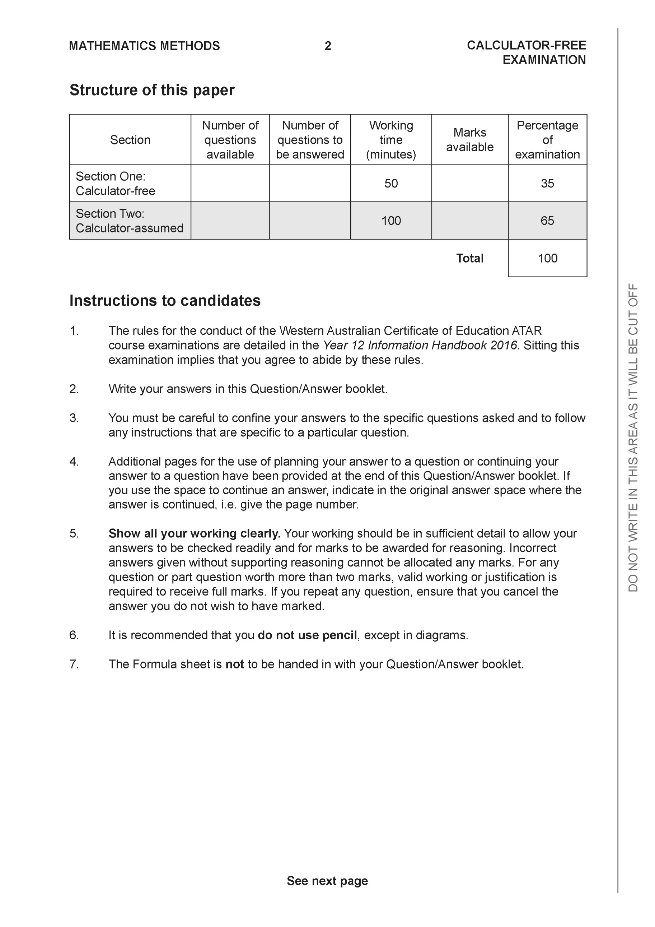

Section One: Calculator-free (49 Marks)

This section has 8 questions. Answer all questions. Write your answers in the spaces provided.

Spare pages are included at the end of this booklet. They can be used for planning your responses and/or as additional space if required to continue an answer.
● Planning: If you use the spare pages for planning, indicate this clearly at the top of the page.
● Continuing an answer: If you need to use the space to continue an answer, indicate in the original answer space where the answer is continued, i.e. give the page number. Fill in the number of the question that you are continuing to answer at the top of the page.

Working time: 50 minutes.

Question 1 (5 marks)
Consider the complex numbers and which are plotted below.

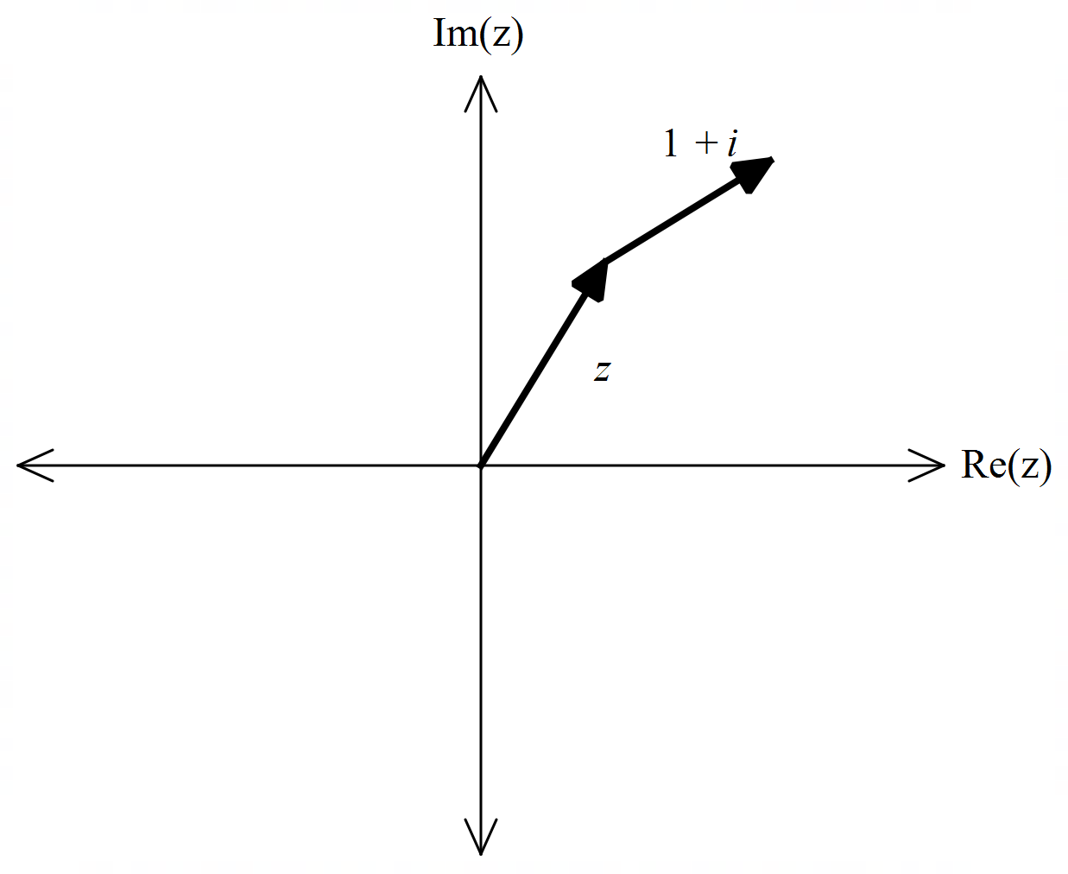

- Express in polar form. (1 mark)

- Determine an exact expression for . (4 marks)

Q1 continued

Question 2 (13 marks)

Consider the two functions as shown below.
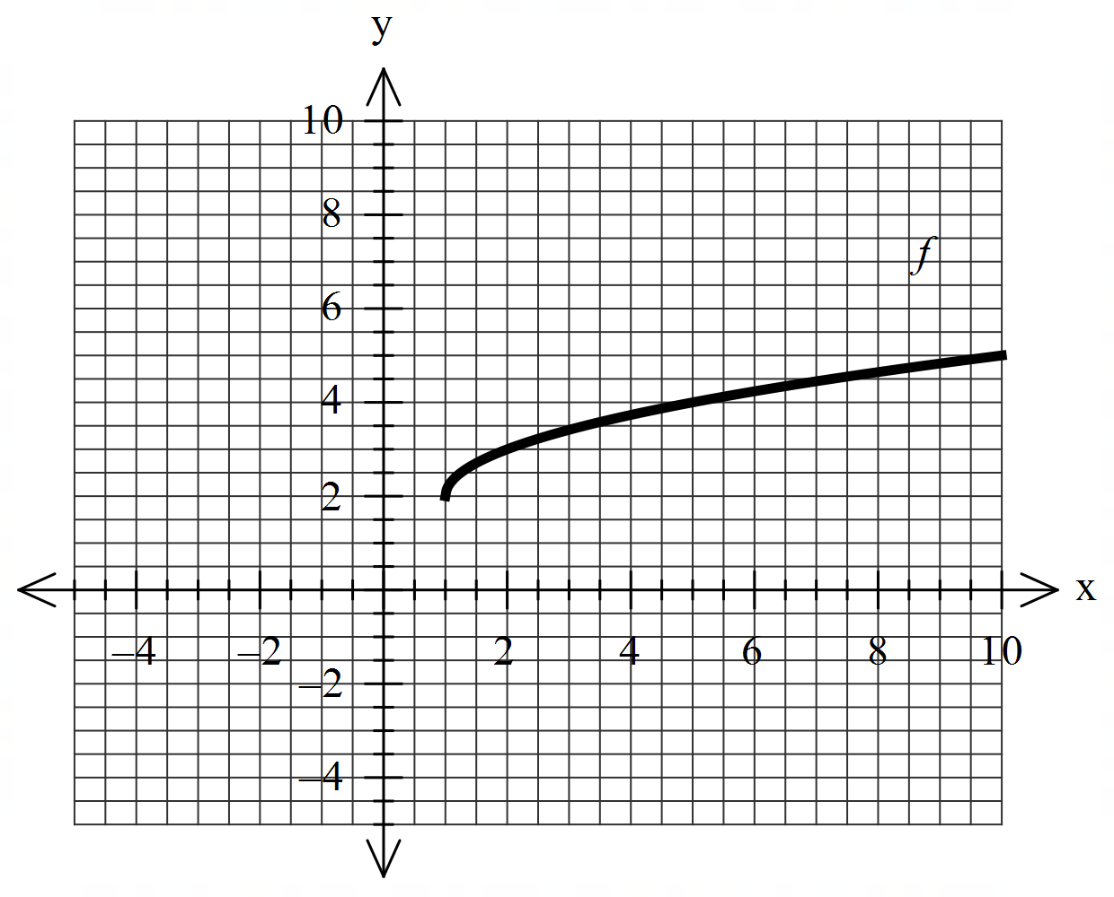 | 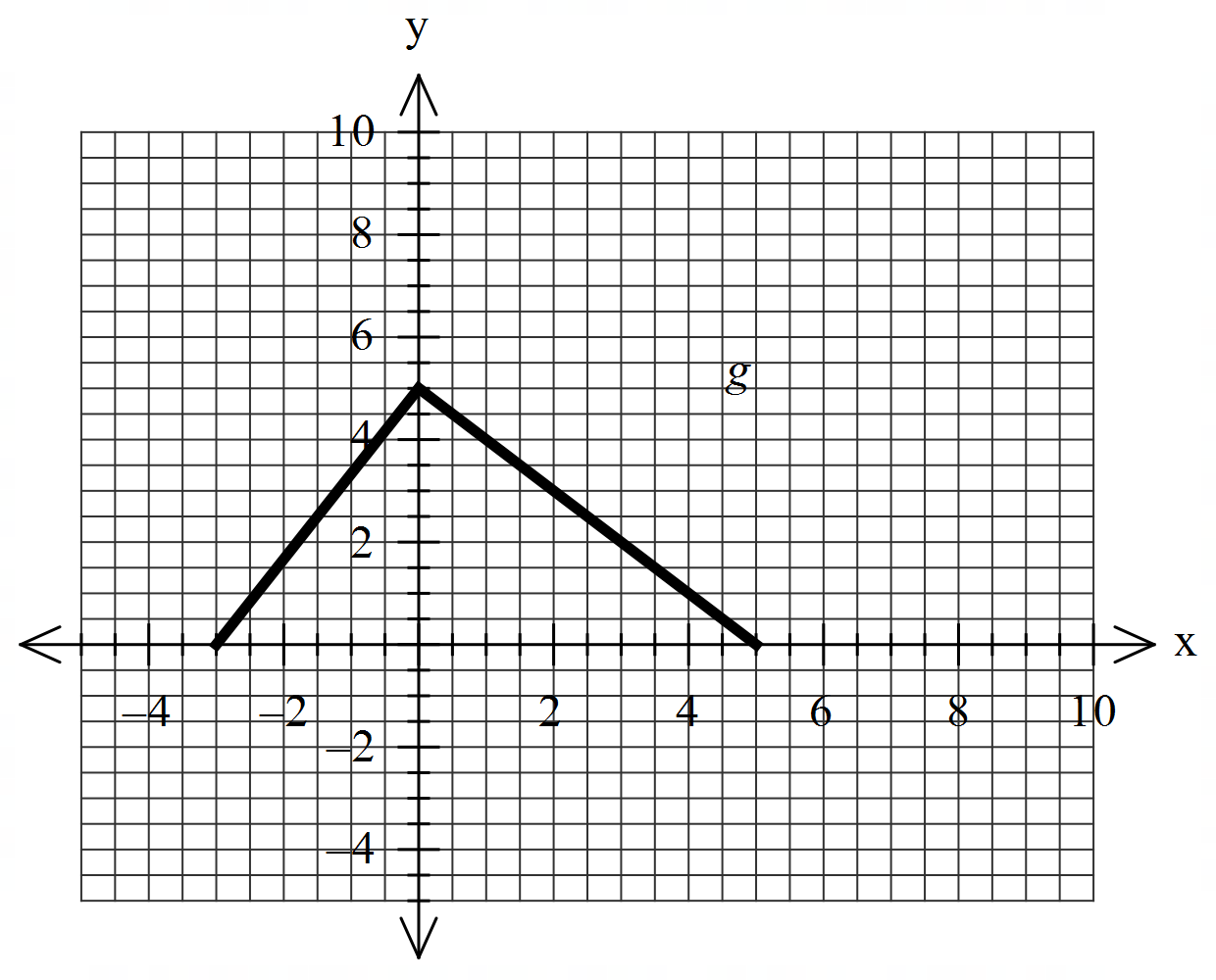
- Sketch the inverse of on the same set of axes. (2 marks)

- Explain why does not have an inverse. (1 mark)

The defining rule for is as follows
- Determine the rule for and state its domain. (3 marks)

Q2 continued
- Determine . (2 marks)

- Does exist for all values of the natural domain of ? Explain. (2 marks)

- Determine the domain and range of . Justify. (3 marks)

Question 3 (5 marks)
Using an appropriate substitution, determine the following integral .

Question 4 (5 marks)
Consider the function . Sketch the function on the axes below showing all asymptotes and major features.

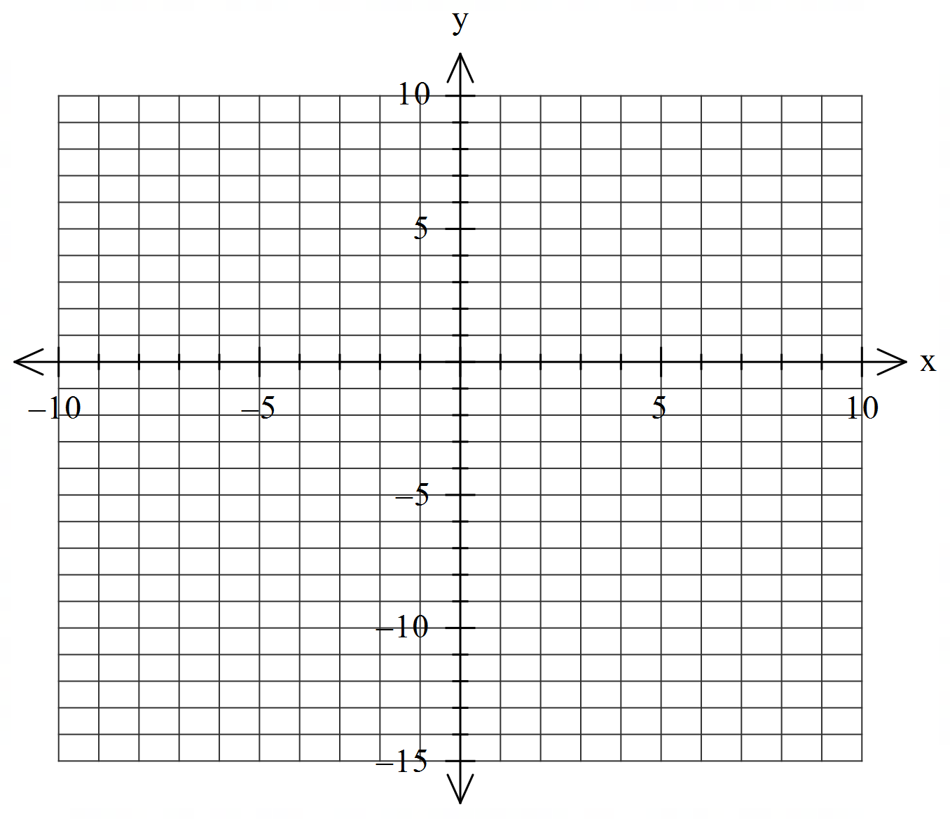

Question 5 (6 marks)
- Given that , determine the values of the constants . (3 marks)

- Hence determine and express answer as one log term. (3 marks)

Question 6 (5 marks)
Consider the polynomial with .
- Determine a quadratic factor of . (2 marks)

- Hence solve the equation (3 marks)

Question 7 (5 marks)
By using and De Moivre’s theorem, determine exact values for .

Question 8 (5 marks)
Determine the indefinite integral showing full working.

Working out space

